# PILOT STUDENTS – Oct/Nov 2015 (this applies to you)

# (1) When you see an instruction to upload something, upload it to your desktop. If faculty needs it, they will ask for it. Contact info is in your FAQ.

# Intro to NoSQL Lab 1: Node.js and IDE

## What Am I Supposed to Do?

1. Follow the instructions of the Lab.
2. Periodically, you’ll be instruction to **STOP** and do what is requested. Typically, we ask you to copy a screen shot. All requested deliverables should be uploaded in the training environment. **YOU MUST DO THIS IF YOU WANT TO PASS THE COURSE!**

## LAB ENVIRONMENT DESCRIPTION:

* The lab is based on node.js as execution platform, Microsoft Visual Studio Code as editor/IDE, Git’s command line for starting/stopping node.js applications, and windows installers for the various databases that will be covered.
* The lab does not use/require a VM, everything will run in your Windows workstation.
* In case you like to do this lab on Linux or Mac OS X that is perfectly fine, we assume you are smart enough to figure out how things work differently in such an environment.

## INSTALL NODE.JS:

Download node.js from <http://nodejs.org/>, and install it  
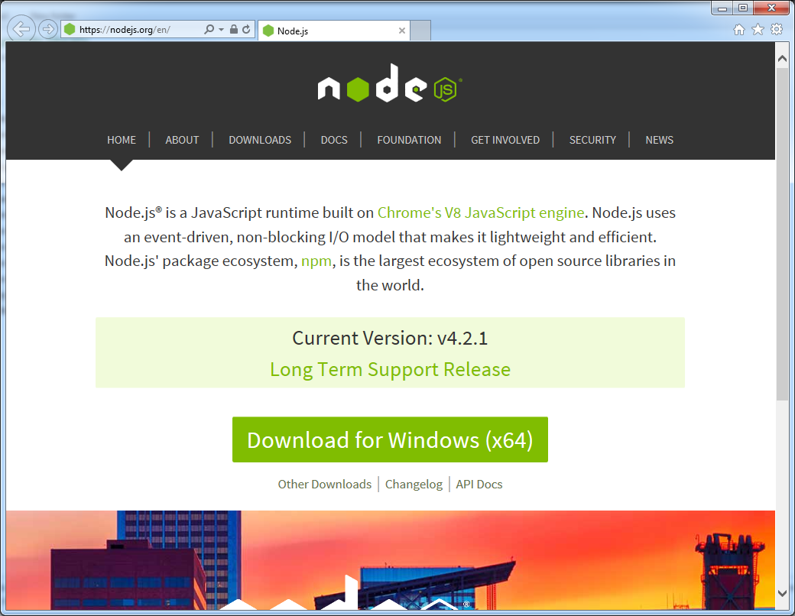  
  
All the default settings are fine  
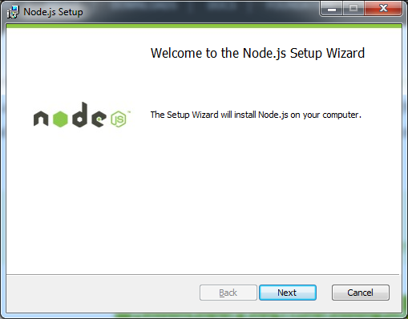 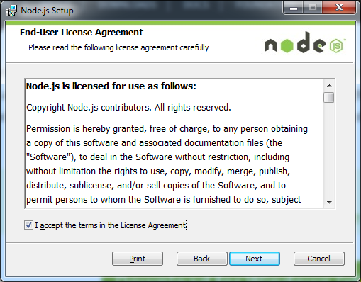  
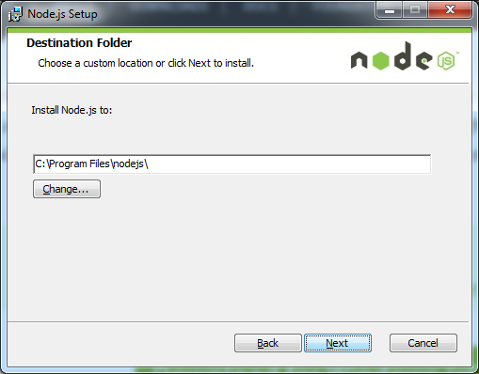 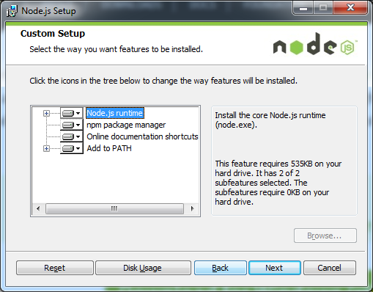  
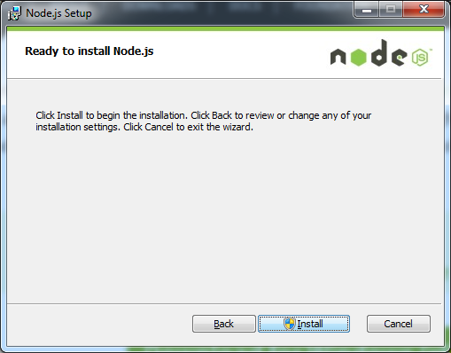 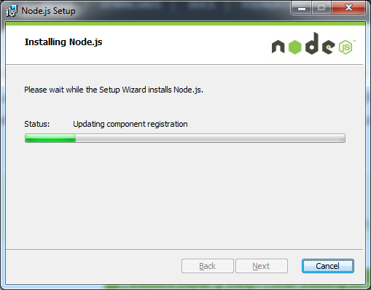  
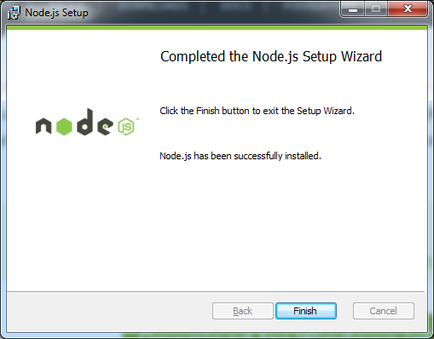

We will run node.js after installation of the other tools below.

## INSTALL VISUAL STUDIO CODE:

Download Visual Studio Code from <https://code.visualstudio.com/> and install it, all default settings will be fine.

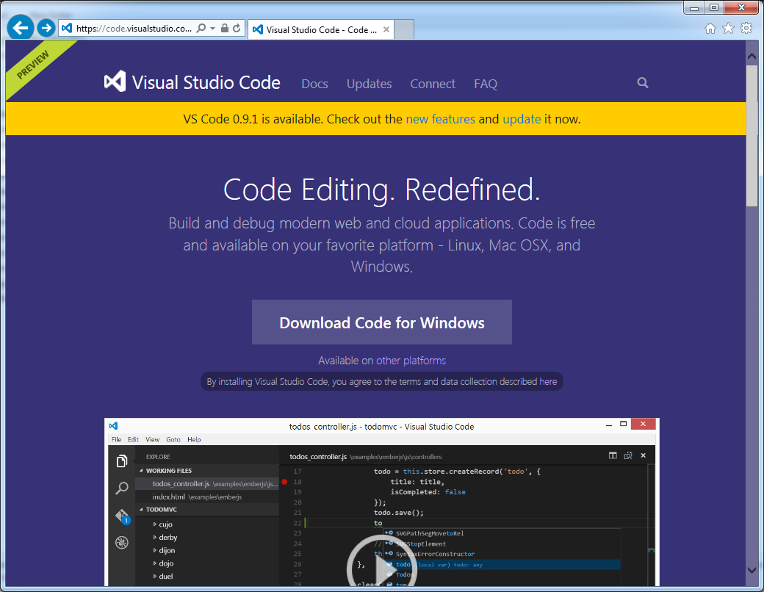

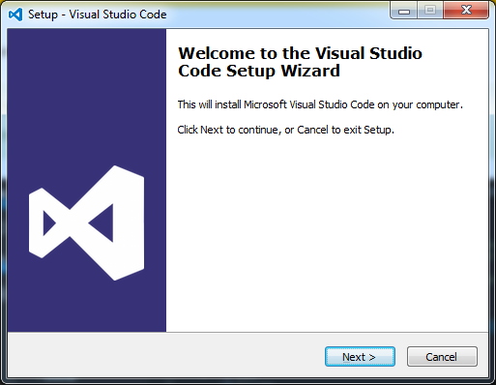 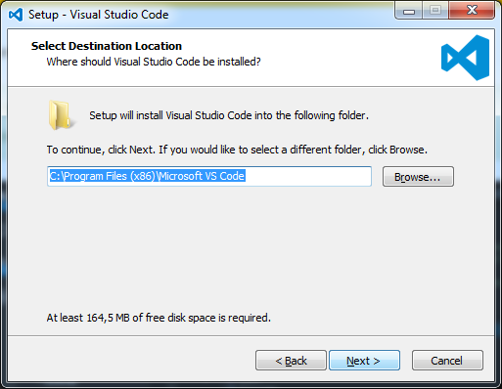

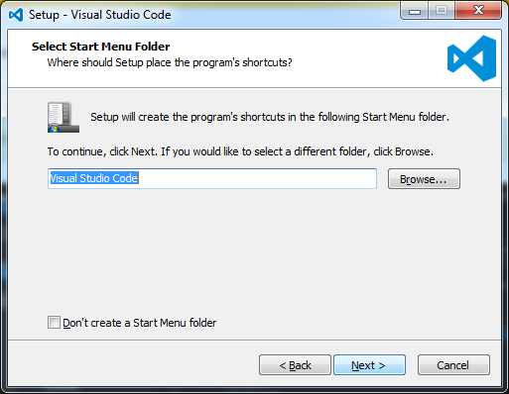 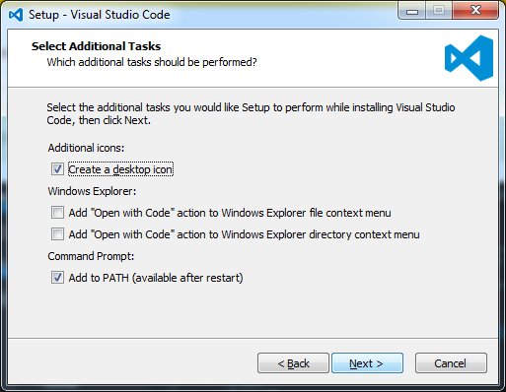

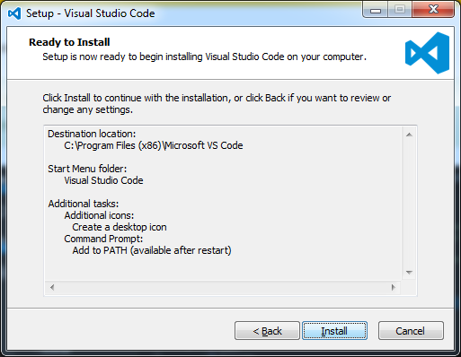 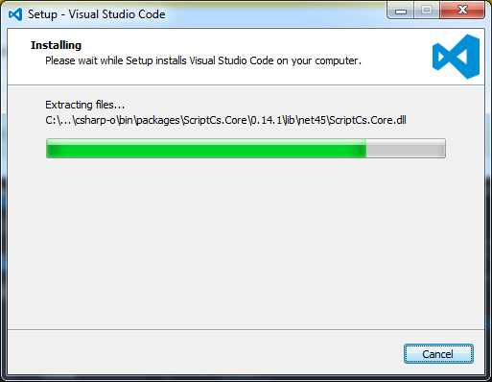 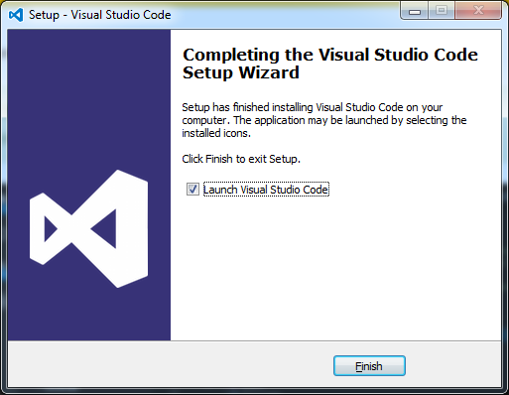

Launching Visual Studio Code should provide a window like this:

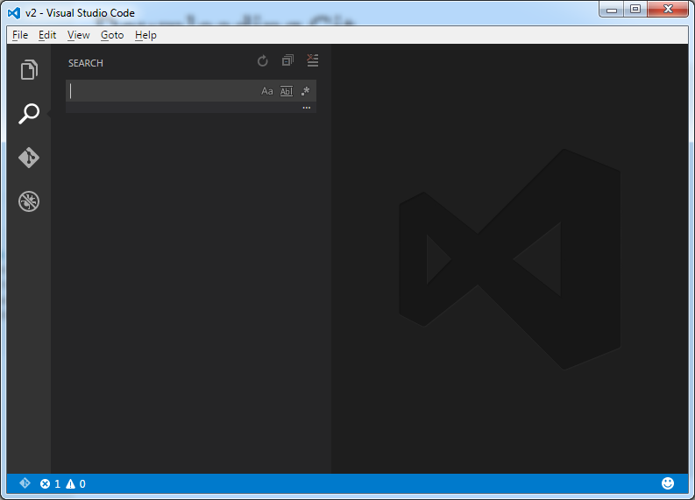

## INSTALL GIT:

This lab will not do any version control, which is normally the reason to use git. The windows installer for Git provides a command line interface that is more comfortable to work with than Windows’ own CLI, which for instance does not support resizing the width of the window.

Download git for Windows 64-bit from <http://git-scm.com/downloads>. Install it with the settings as indicated in the screenshots.

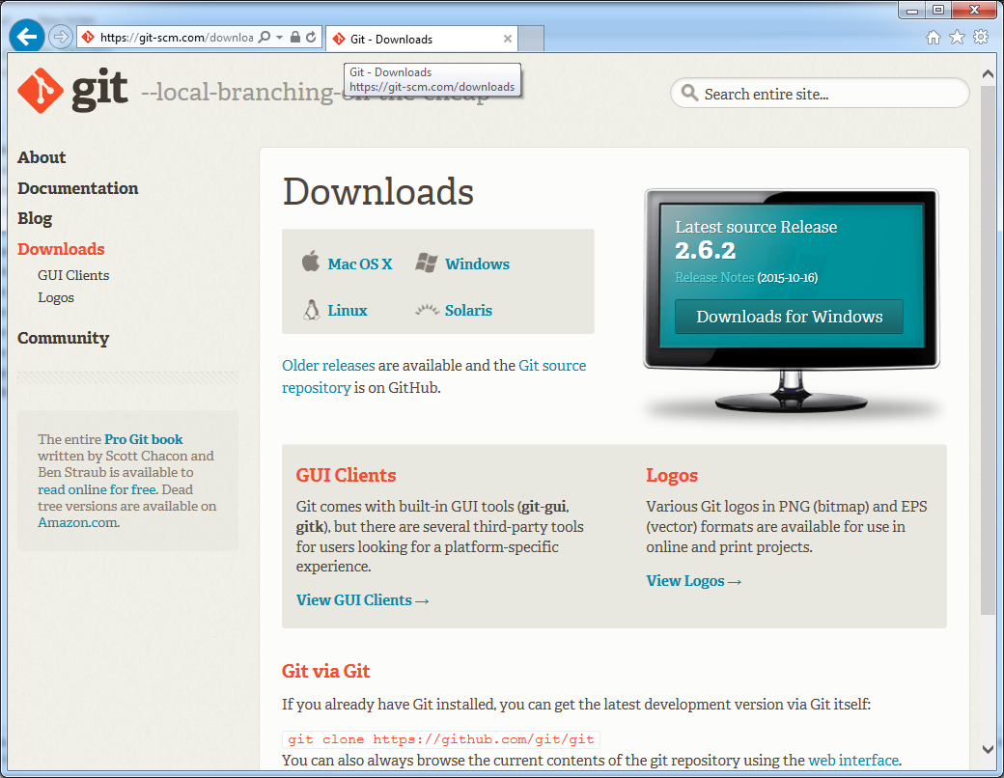

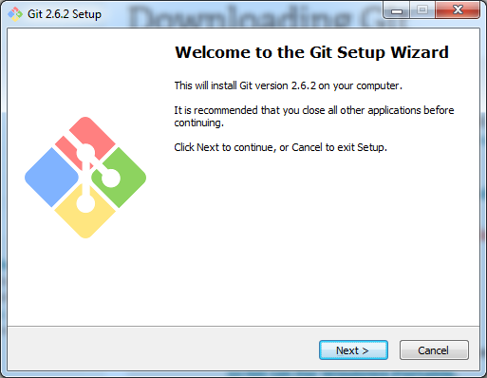 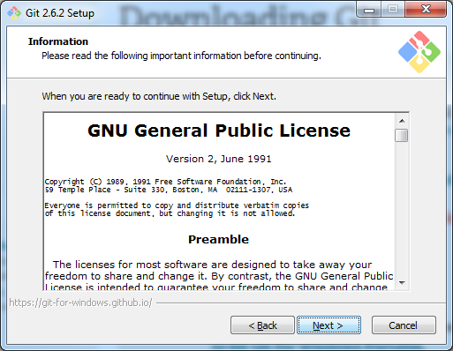

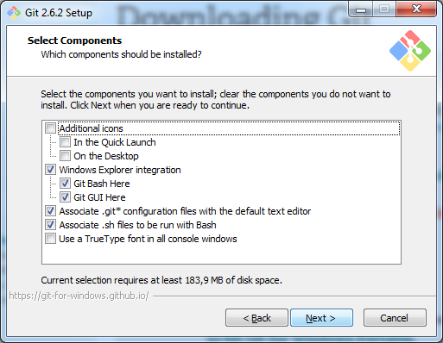 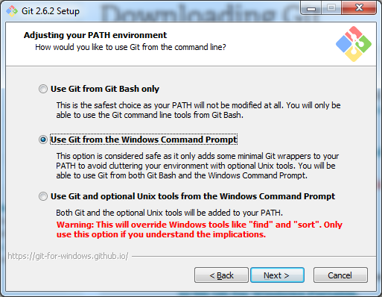

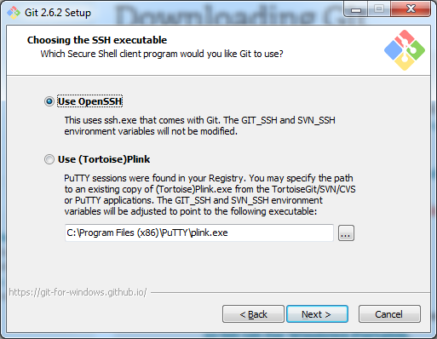 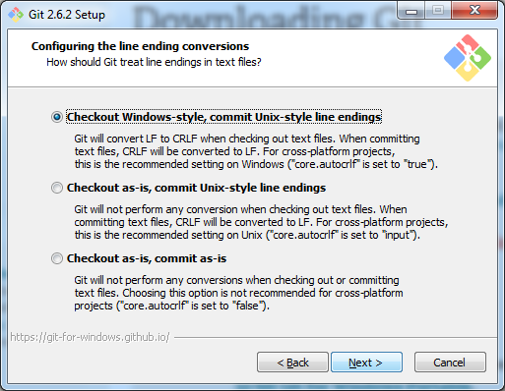

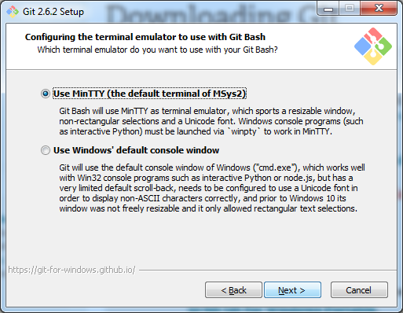 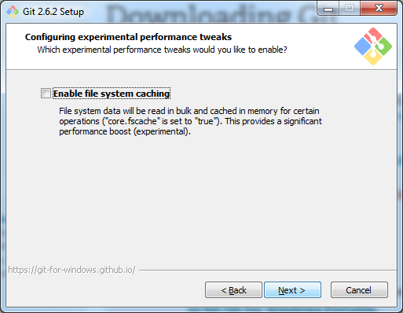

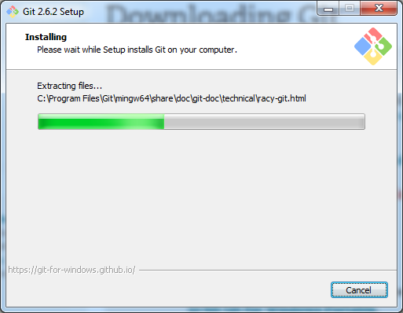 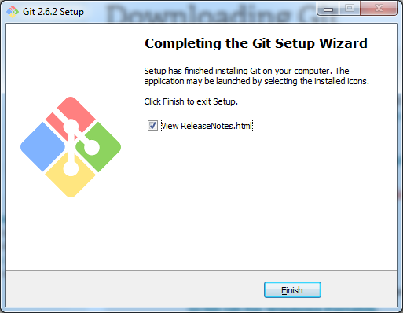

## TEST YOUR INSTALLATION:

In the windows start menu look for an application called Git Bash 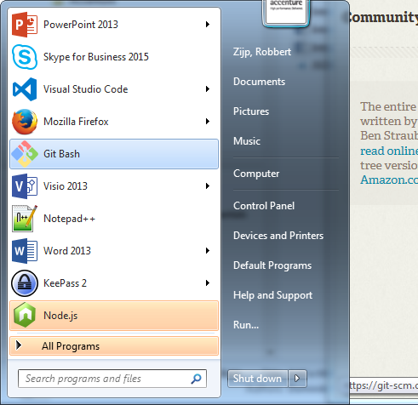

Launching Git Bash should give a window like this:

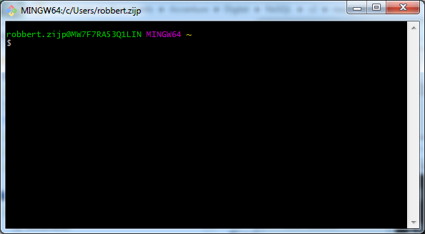

On the command line, type node --version. If this returns v4.2.1, you’re all set.

**STOP** and make a screenshot of your working Git Bash (you’re enterprise id should be in it)

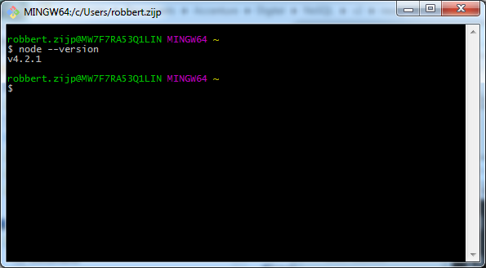

## NODE.JS HELLO WORLD:

1. Unpack the nosql-lab-nodejs-fundamentals.zip in your folder of choice, and change directory (cd) to that folder on the command line. Execute an ll (long list) to validate that your folder contains a subfolder called helloworld. Navigate into that folder. 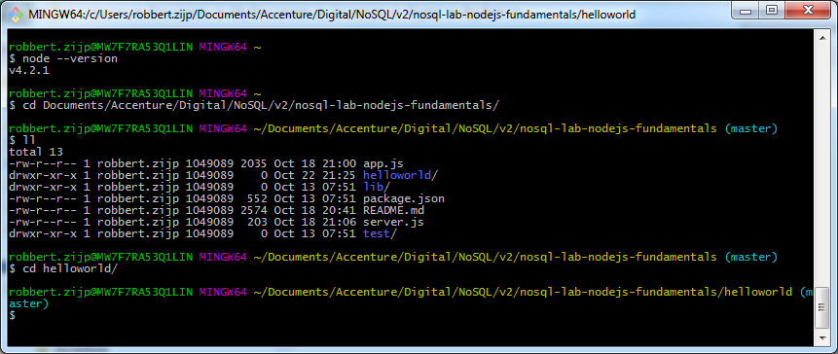
2. Try a node hello_console.js, this should echo back to the command line (console).

( using supervisor , it will restart on code changes --- npm install supervisor –g)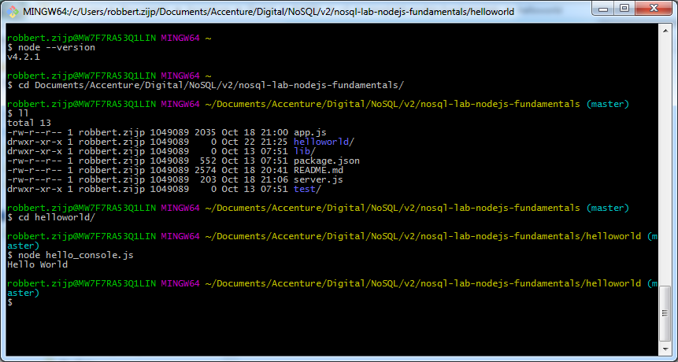

1. Then try node hello_http.js. This should start a very tiny webserver that will listen on the localhost. 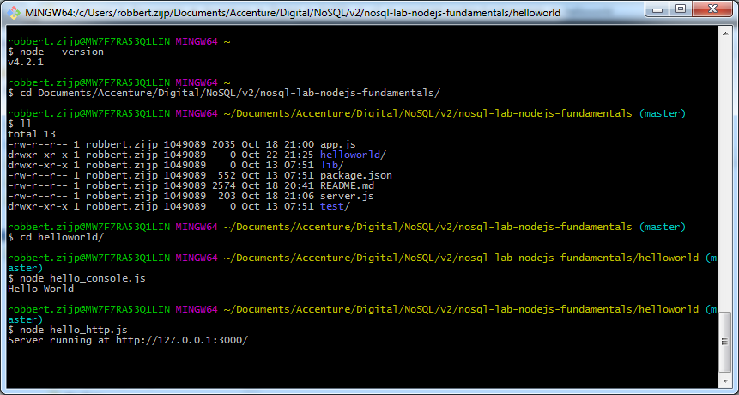
2. Open the URL <http://127.0.0.1:3000/> in your browser. 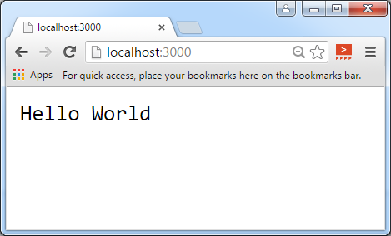
3. Halt the listening webserver with Ctrl-C.

**STOP** Open the file hello_http.js in Visual Studio Code, alter it to have node.js great yourself, save and run it again, reload your browser, and make a screenshot (it should show your name of enterprise id).